Associate Editor

Comments to the Author:

1. As authors mentioned, this topic has been investigated in previous study (Ref 31). Authors need to clearly demonstrate the novelty of this study compared with the previous study in introduction.

**Response:** We agree and have added text to the updated manuscript’s Introduction section. On page 3 of the revision, we write: “Few studies have estimated the number and timing of BP measurements required to obtain an estimate of mean BP during sleep similar to that obtained by a full night of ABPM (i.e., using ABPM throughout an entire night). Others have previously studied the validity of using a fixed number of BP measurements, sampled randomly during wakefulness or sleep, to determine how many measurements were needed for reliable estimation of mean BP in the research setting. In the current study, we investigate the specific timing, as well as the number, of measurements needed for reliable estimation of mean BP during sleep.”

2. Please revise the reference 3 into the latest version (Hypertens Res 2019; 42: 1235-1481).

**Response:** Thank you. The reference has been corrected.

Reviewer: 1

This paper investigated the optimal number and timing of the BP measurements during sleep which may have high agreement with the diagnosis of nocturnal hypertension based on a full night of ABPM. The results showed that measuring BP 3 or 4 times during sleep with at least 1 hour between measurements resulted in high agreement with a full night of ABPM. The method for evaluating the different sampling variations was systematic and clear. I have only one minor comment:

BP sampling at 1, 2, 4, and 5 hours after falling asleep had not only the highest Kappa statistic for nocturnal hypertension but also the lowest mean absolute difference (3.11) for mean systolic BP during sleep. It is an interesting finding and it should be discussed more. I do think that the agreement in the absolute BP value is of interest to readers of this journal.

**Response:** We agree with the reviewer and have modified the Results and Discussion sections of the manuscript to draw more attention to this finding. In the Results section on page 10, we have written “For the sampling variation with the highest Kappa statistic in the pooled cohort – BP sampled at 1, 2, 4 and 5 hours after falling asleep – participants sleep SBP and DBP differed by an average of 3.11 (95% CI 2.97, 3.26) and 2.66 (95% CI 2.53, 2.78) mm Hg, respectively, from the corresponding asleep SBP and DBP calculated from a full night of ABPM. For SBP, this was the lowest mean absolute difference obtained by any of the BP sampling variations.”

We have modified the Discussion section. In the first sentence of the opening paragraph (see page 12), we write “In the current study, the highest Kappa statistic assessing agreement with nocturnal hypertension based on a full ABPM assessment, and lowest mean absolute difference for estimating mean SBP during sleep, resulted from sampling BP at 1, 2, 4, and 5 hours after falling asleep.” Later in this paragraph, we write “The low mean absolute differences of 3.1 mm Hg and 2.7 mm Hg for SBP and DBP, respectively, when sampling BP at 1, 2, 4, and 5 hours after falling asleep suggests that this approach may be a suitable method to approximate mean BP according to a full night of ABPM.” Last, in a separate paragraph of the Discussion Section (see page 14), we write “The current study found a mean absolute difference of 4 mm Hg in SBP between a full night of ABPM and measuring BP at 2am, 3am, and 4am.”

Reviewer 2:

The aim of this observation study was to assess whether a limited number of blood pressure (BP) measurements could provide an accurate estimate of mean BP from a full night of ambulatory BP monitoring (ABPM) in the Jackson Heart Study and the Coronary Artery Risk Development in Young Adults (CARDIA) study cohort (n=1,079, mean age 57.1±8.6 years, 32.0% male, 81.0% black). This study assessed the Kappa statistics of nocturnal hypertension among each BP measurement timing. This study demonstrated that measurement BP at 3 times (2, 3, and 4 hours after falling asleep) or 4 times (1, 2, 4 and 5 hours after falling asleep) during sleep would show high agreement with the status of nocturnal hypertension assessed by a full night of ABPM.

Comments

・Although this study estimated the accuracy of nocturnal hypertension using different timing of nocturnal BP measured by ABPM for applying for the estimation of nocturnal hypertension using home BP monitoring (HBPM), I think HBPM and ABPM would be entirely different. Recent study demonstrated that nocturnal hypertension defined by HBPM were significant risk factor for future cardiovascular disease event, on the other hand, that defined by ABPM were not.(Mokwatsi GG, et al. Hypertension. 2020;76:554-561.) How do you think about the differences between HBPM and ABPM? I agree that fewer BP measurements during asleep would reduce discomfort and disrupted asleep. So, the results of this study would have much potential to apply for HBPM.

**Response:** We agree that associations between cardiovascular events and out-of-office BP may differ when nocturnal BP is measured with HBPM rather than ABPM. We conducted the current study to inform future studies that would use an HBPM device specifically designed to automatically take a limited number of BP readings during sleep. In light of the recent results from Mokwatsi et al, we have updated our Discussion section. On page 13-14, we write

“In the Japan Morning Surge Home Blood Pressure (J-HOP) study, mean BP from a self-measured HBPM device programmed to measure BP at 2am, 3am, and 4am was associated with LVMI and ACR, independent of clinic BP and home BP during the morning and evening.14 The current study confirms these results by showing that BP measured 2 to 4 times using ABPM during sleep is associated with LVH and albuminuria in other cohorts. Another analysis of the J-HOP data found that the average of BP readings assessed at 2am, 3am, and 4am over an average of 8.89 nights, using the same HBPM device, was associated with incident CVD events, but found no evidence of association between mean BP from a single night of ABPM and CVD. The current study found a mean absolute difference of roughly 4 mm Hg in SBP between a full night of ABPM and measuring BP at 2am, 3am, and 4am. Future studies should identify whether the additional prognostic value of HBPM versus ABPM for incident CVD risk persists when both techniques are repeated over multiple nights.”

・I think the authors should describe clearly that the gold standard for measuring nocturnal BP levels still have been an ABPM.

**Response:** On page 3 of the revised manuscript, we write “Ambulatory BP monitoring (ABPM) typically measures BP every 15 to 30 minutes throughout the day and night, and is recognized as the gold standard for measuring nocturnal BP.”

・The authors had better show the mean BP levels of each measurement timing.

**Response:** We think this is an excellent idea and have added two figures (see Figures S1 and S2) in the revised manuscript that show mean SBP and DBP during sleep for the current study. In addition, we have tabulated the mean SBP and DBP according to each BP sampling variation (see Table S3). For convenience, Figure S1 is shown on the next page of this response to reviewer comments. In the manuscript, we have updated the text to indicate the addition of these results. Specifically, in the Methods section on page 7, we write “The mean and standard deviation of SBP and DBP according to each BP sampling variation was tabulated along with the mean SBP and DBP according to a full night of ABPM. Linear regression with a natural cubic spline was applied to visualize the mean SBP and DBP over time from midnight to 5am and from onset of sleep to 5 hours thereafter among CARDIA and JHS participants, separately.” In the Results section on page 9, we write “Many BP sampling variations underestimated the mean SBP and DBP according to a full night of ABPM by 1 to 2 mm Hg (Table S3). This underestimation is likely attributable to higher BP levels during the later stages of sleep, as indicated by SBP and DBP during sleep for participants in the current study (Figures S1 and S2).”

**Figure:** Estimatedmean systolic blood pressure values among participants in the Coronary Artery Risk Development in Young Adults study (top row) and the Jackson Heart Study (bottom row). Mean values are drawn with respect to time since falling asleep (left column) and time since midnight (right column).

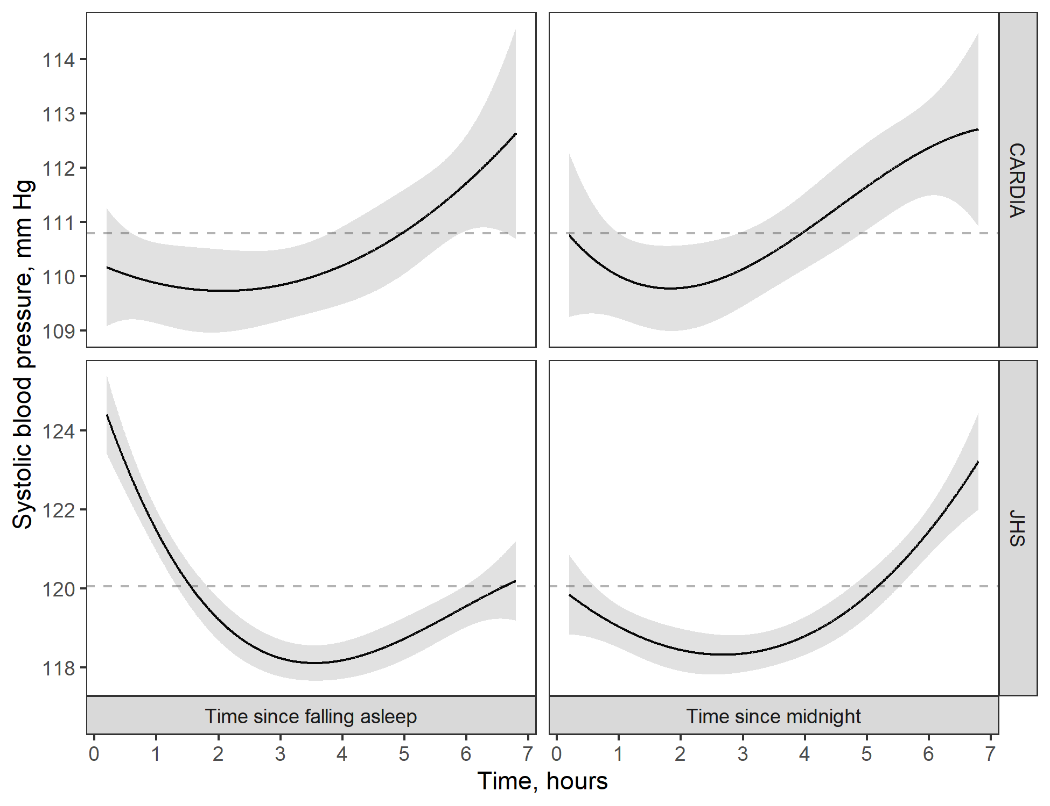

Blood pressure was estimated using linear regression with a natural cubic spline to capture nonlinear patterns in blood pressure over time.

Shaded area around the black lines show 95% confidence limits for the blood pressure estimates.

The grey dashed line shows the mean systolic blood pressure during sleep for participants in the Coronary Artery Risk Development in Young Adults study (top row) and the Jackson Heart Study (bottom row)

・I would like to ask the authors why BP measured by 2, 3, and 4 hours or 1, 2, 4 and 5 hours after falling asleep would be important for diagnosing nocturnal hypertension.

**Response**: We speculate that BP measured by 2, 3, and 4 hours or 1, 2, 4 and 5 hours after falling asleep would be important for diagnosing nocturnal hypertension because these sampling times tend to coincide with the period of sleep when BP is dipping, rising, or at its minimum point during sleep. Therefore, the BP at these sampling times may yield estimates that are closest to that of full ABPM because they average over both the diurnal pattern and diurnal fluctuations in BP during sleep, i.e., they capture the U-shaped BP curve that usually occurs during sleep. We have not made any changes to the manuscript based on this response.

・In addition, do you think that bedtime-based nocturnal BP measurement (e.g., 2, 3 and 4 hours after falling asleep ) would be more important for diagnosing nocturnal hypertension compared to fixed-time nocturnal BP measurement (e.g., 2:00, 3:00 and 4:00)?

**Response**: It is difficult to determine which time definition (i.e., time since midnight versus time since falling asleep) is more important for diagnosing nocturnal hypertension because both time definitions performed similarly in terms of Kappa statistic and mean squared error. However, in cases where study participants go to sleep at a broad range of times, using time since falling asleep will be more likely to successfully straddle the U-shaped BP curve that usually occurs during sleep. Hence, we speculate that using time since falling asleep to diagnose nocturnal hypertension with 3 or 4 BP readings will be preferable in future studies. Based on this comment, we have added a short paragraph to the Discussion section. On page 14, we write

“The current study assessed sampling variations of BP at specific times relative to midnight and sleep onset. Although both approaches are valid, the latter may be more likely to adequately measure BP during sleep in samples where participants go to sleep at a range of times. Study participants may also prefer the latter definition as it does not require them to be asleep at specific times. Future studies should investigate the reliability of and preference for HBPM devices that are programmed to measure BP at times relative to midnight versus relative to the onset of sleep.”

・As you have described as a study limitation, I think the results of this study could not apply for the elderly, who generally wake up early and did not sleep over 5 hours.

**Response:** Thank you for pointing this out. We have modified the text concerning this limitation. On page 15, we write “Results from the current study may not generalize to settings where participants sleep for <5 hours or miss planned BP measurements, e.g. older adults who typically wake up early and often do not sleep for 5 consecutive hours.”

・I think the results of this study would statistical, not practical. How do you apply the results of this study for the management of hypertension?

**Response:** The current study’s findings are applicable to investigators conducting research on sleep BP. For example, investigators may decide to measure BP at 1, 2, 4, and 5 hours after participants fall asleep in their study so that (1) they are likely to obtain valid estimates of asleep BP that show high agreement with the estimates that would have been obtained if a full night of ambulatory BP monitoring was completed, (2) participants are less likely to experience sleep disturbance, and (3) participants may be more likely to agree to repeat the monitoring of BP during sleep if the procedure causes little or no sleep disturbance. Additionally, the results may have clinical relevance in the future if monitoring nighttime BP becomes standard practice in the clinical management of BP and hypertension. To emphasize the implications of the current study, we added the following sentence to conclude the revised paper (see page 15): “Investigators of sleep BP may find the current study’s results relevant for designing and implementing future studies that measure BP during sleep, as the use of 3 to 4 BP measurements instead of 16 or more BP measurements could improve study recruitment and increase the likelihood of participants agreeing to have their sleep BP assessed multiple times. Results from the current study also suggest desirability for HBPM devices that measure BP at specific times during sleep, allowing users to program the number of readings and specific assessment times.”